**Srilanka Institute of Information Technology**

**English For Academic Purpose**

**IT1080**

**Importance of renewable energy in current Sri Lanka**

**MLB_05.02_11**

❖ Topic: Importance of renewable energy in current Sri Lanka

❖ Course Code: IT1080

❖ Date: 20.04.2022

❖ Batch: MLB_05.02_11

Group Details:

|  | Student  Registration Number | Student Name |
| --- | --- | --- |
| 1 | IT21282072 | Satkurulingam.S |
| 2 | IT21261978 | Sriskandarajah J. P |
| 3 | IT21223808 | Linganathan .J |
| 4 | IT21301254 | Silva A.A.I |
| 5 | IT21296628 | M.M.Nishala Dewanthi |

**Terms of Reference**

This report contains “**Importance of renewable energy in current Sri Lanka”**. It is submitted as a requirement of the 1st-year 2nd semester English for Academic Purpose module (EAP_1080) of BSc (Hons) in Information Technology, Faculty of Computing, Sri Lanka Institute of Information Technology, Malabe, Sri Lanka.

**Acknowledgment**

Everyone in our team gave their full contribution to our project titled “Importance of renewable energy in current Sri Lanka”. The project could not have been completed successfully without the contribution of everyone. Every member of our group participated in all discussions related to our project.

We would like to express our sincere gratitude to our lecturer Ms. Umeshi for providing her guidance and to all lecturers who guided us on this project under the EAP Module to complete this successfully. Also, we extend our heartfelt thanks to our friends as well as our seniors. Because they also helped us as much as they could.

**Abstract**

In the current situation in Sri Lanka, we are facing many difficulties due to the energy crisis. The total country is affected by the energy crisis. As a result of the energy crisis, we are having power cuts and also, we don’t have enough fuel for our vehicles. The best solution for the energy crisis is to use renewable energy. This report mainly includes some information such as an explanation of renewable energy and the importance of renewable energy sources in current Sri Lanka. We are using renewable energy for the past few years in our country. However, the usage of renewable energy is not improved like in some other developed countries like India and China. This report also has a bar chart related to that.

Overall this report is explaining what is renewable energy, the energy crisis in current Sri Lanka, the importance of renewable energy in current Sri Lanka, and various renewable energy sources are used in Sri Lanka nowadays. From this report, a person can get full knowledge about renewable energy and its usage in present Sri Lanka.

**Table of Contents**

**Introduction 7**

**Methodology 8**

**Explanation of renewable energy 9**

**Energy crisis in Current Sri Lanka 9**

**Renewable energy is the only solution to Sri Lanka’s power crisis 10**

**Growth and development of renewable energy sources in Sri Lanka 12**

**Various types of Renewable energies using in Sri Lanka 13**

**Biomass Energy 13**

**Hydropower 13**

**Solar Energy 13**

**Wind Energy 14**

**Other Renewable Energy Sources 14**

**Conclusion 16**

# Introduction

Energy and related sectors are critical to Sri Lanka's development profile. Because of population growth and industrial revolutions, energy demand is increasing all the time. To meet such growing demands, we are likely to rely on fossil fuels in large quantities, which has many negative environmental consequences. As a result, the government decided to launch several long-term and short-term initiatives to promote the renewable energy sector in Sri Lanka, as it has a lower environmental impact and higher quality than fossil fuels. However, our country is in a very bad situation as the government has not implemented any of these projects properly.

In today’s scenario fuel shortage is a massive problem in Sri Lanka. That is why power cuts have been implemented in our country for many hours. Thus, everyone from ordinary people to the most affluent people is most affected. Not only the power outage but also the transportation services have been affected due to this energy crisis in our country. Power outages have become common in Sri Lanka, despite repeated assurances from the government that sufficient fuel had been purchased for electricity generation. As a result of that protests are being held in many parts of the country. The only solution to all these is to generate electricity in a recirculating manner. So, we have to use renewable energy in our country. Given the country's current power generation challenges, stakeholders in the renewable energy sector have volunteered to propose what they believe is the solution to the country's current energy crisis.

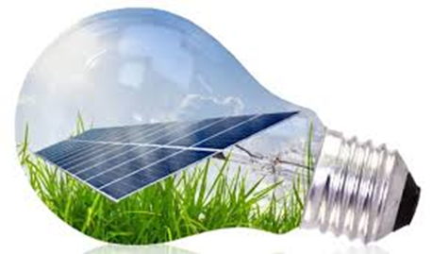

# Methodology

This report's data and information were mostly gathered from online sources. In addition, some data were gathered through the use of magazine and newspaper articles. The above-mentioned methods were used to collect the majority of the data. Aside from that, some of the information was gathered by referring to books and other sources of information.

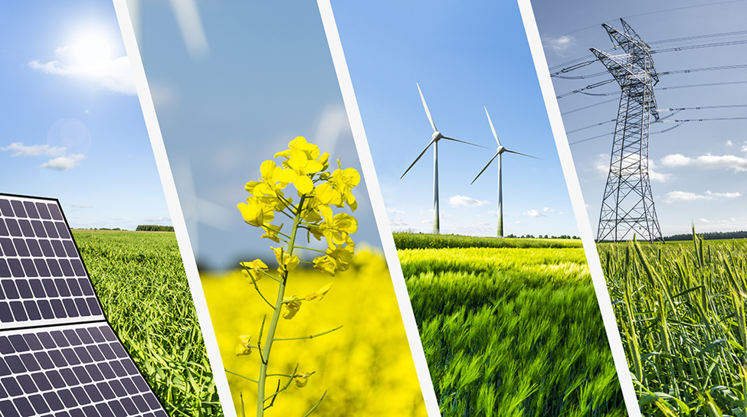

Various types of renewable energies are used in Sri Lanka.

# Explanation of renewable energy

If a natural resource can be converted into a usable form of energy, it is considered an energy resource. There are many different types of energy resources in the world, and different countries use different ones, based primarily on availability and economic principles. However, environmental and political factors also influence a country's energy portfolio selection.

Renewable energy is defined as energy derived from resources that are renewed naturally on a human timeline. Solar energy, wind energy, tidal energy, and geothermal energy are examples of renewables. Renewable energy is defined as energy that will not deplete or be easily replaced (like slow-growing trees). Any source of energy that is renewable is referred to as renewable energy which can be used by the current generation without jeopardizing the ability and right of future generations to consume energy resources. Solar energy is the most fundamental kind of renewable energy. All of these renewable energy sources are reliant on the sun. Except for geothermal energy, which is a renewable energy source that is not dependent on solar energy.

Renewable energy sources are ideal for our energy portfolio because they are infinite and do not pollute the environment. Nearly every municipality, on the other hand, has access to natural resources such as sunlight, wind, and geothermal energy. As a result, harnessing these renewable energy sources might be a powerful democratizing factor, providing affordable and plentiful power to people all over the world. As a result, it is critical to suggest potential renewable energy supplies for meeting energy demand without harming the environment or degrading the quality of life.

# Energy crisis in Current Sri Lanka

Electricity is one of the most important services that contribute to a country's development. Without exception, Sri Lankan industries rely entirely on a reliable, competitively priced, and long-term power generation system for growth. It is a well-known fact that over the last three decades, the power generation sector in Sri Lanka has failed to meet the expectations of industry, services, and the general public in terms of quality, reliability, and capacity. Even so, the country’s power generation has plummeted this year.

This year, fuel scarcity is a major issue in Sri Lanka. As a result, our country has been subjected to lengthy power outages. As a result, everyone, from the most affluent to the least affluent, is most affected. The energy crisis in our country has impacted not only power outages but also transportation services. Despite repeated assurances from the government that sufficient fuel had been purchased for electricity generation, power outages have become common in Sri Lanka. As a result, protests are taking place in many parts of the country. As a result of the energy crisis, there have been massive problems in the academic activities of the students. More specifically, university students are unable to even learn online. Not only that but even those who work in IT companies lost their jobs. Thus the whole country is in darkness in today’s situation. Not only this year but every year our country is experiencing power shortages due to climate change and declining rainfall. However, the power outage lasted for about 14 hours like this no other.

# Renewable energy is the only solution to Sri Lanka’s power crisis

The solution is for the country to move on to more renewable sources of energy such as wind, solar, biogas, biomass, and hydropower. Renewable energy also presents a host of other benefits both socially and economically.

In the face of depleting foreign currency reserves and capacity constraints, the only logical solution is to make renewable energy the primary source of energy production. Natural resources can be used to generate renewable energy. This would also provide some relief to the world's dwindling foreign reserves, as renewable energy does not require fuel imports.

With the global price of oil, coal, and gas rising, it is no longer sustainable for countries like Sri Lanka to import fossil fuels, increasing their reliance on non-renewable energy sources. It is preferable to transition to renewable energy sources sooner rather than later so that the country's economy is not jeopardized further.

"Our goal as the renewable energy sector is to help the Government and its people overcome the current energy crisis," said the Past President of HPDA at a recent press conference. We believe that increasing cooperation between the government and the private sector is the key. Only then will we be able to overcome all obstacles and make the transition to renewable energy."

There are currently 294 private sector renewable energy development projects that have been commissioned. The total capacity of these projects is 718.334 megawatts (MW). To reap the full benefits of renewable energy, the total number of projects must be significantly increased.

One of the most pressing issues confronting the renewable energy sector is the lengthy government approval process. It should be streamlined and implemented most efficiently and effectively possible. Renewable energy developers have also encountered a slew of issues from the CEB, including delays in approval and grid connections that have been attributed to incorrect technical analysis. These issues could be resolved by instilling sound technical know-how and international best practices in the CEB. Importation restrictions have also hampered the success of the renewable energy sector, making it difficult to obtain the necessary equipment.

Aside from the immediate benefits to the country, renewable energy sources are also less harmful to the climate and environment. This will help to protect the environment and ensure future development is not hampered by environmental issues. Many domestic and foreign investors have expressed interest in renewable energy. We must raise awareness and persuade them that it is a worthwhile investment with few or no barriers. Only then will Sri Lanka be able to overcome its socio-economic problems and continue its development.

# Growth and development of renewable energy sources in Sri Lanka

Most tea plantation enterprises in Sri Lanka have been employing renewable energy for electricity generation since the early twentieth century. Small hydropower plants are being installed. It is now well acknowledged that addressing the energy needs of an economy aiming for rapid growth while guaranteeing environmental sustainability is a major problem for emerging countries like Sri Lanka. A major focus was Energy Challenges in the Knowledge Economy. With the consistent economic expansion, energy demand is critical, particularly for a developing country like Sri Lanka.

Energy security should be a top concern for national planners, who should develop a national energy policy by selecting a sustainable energy mix that takes into account the various growth sectors, particularly industry and services. Sri Lanka is on its way to becoming a middle-income country with international competitiveness. This power and energy sector development plan is in line with the country's development goals, and it aims to provide affordable, high-quality, and reliable energy to all citizens, rich and poor, on an equal footing, while preserving the country's valuable natural environment, prioritizing indigenous energy sources, and reducing regional disparities in energy service delivery.

The power and energy sector's objective is for Sri Lanka to become energy self-sufficient by harnessing the full potential of all renewable and other indigenous resources. In 2013, the country's overall energy demand was roughly 11,125 ktoe, with biomass accounting for 4,814 ktoe, fossil fuels accounting for 4,582 ktoe, and hydro accounting for 1,442 ktoe. As a result, indigenous energy accounts for 56 percent of total energy consumption (biomass + hydro).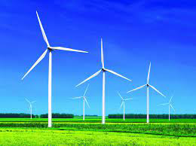

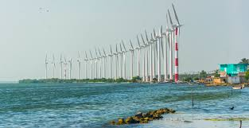

Wind Turbines are mostly used in Sri Lanka to produce electricity.

# Various types of Renewable energies using in Sri Lanka

## **Biomass Energy**

As a result of the high plant growth rate caused by the high incidence of solar radiation and rainfall, Sri Lanka has a great potential for producing biomass from a unit area. It is anticipated that by converting marginal land to fuelwood plantations and enhancing the productivity of other cropland and household gardens, roughly 40 billion kg of biomass can be generated [Energy Conservation Fund, 2005]. This resource's total potential is estimated to be around 16 million tons of oil equivalents (Mtoe) per year. However, around 70% of biomass energy production is done informally. Biomass is Sri Lanka's most widely used renewable energy source.

## **Hydropower**

Sri Lanka has a high hydropower potential due to its geographical configuration, which includes rain-fed central hills. The hydropower potential of a moving or flowing body of water is defined by two aspects: the amount of water that passes through a point during a given period and the vertical drop through which the body of water passes. As a result, large amounts of water and sudden drops are referred to as good hydropower resources. For millennia, the country has used this resource to transport irrigation water, and for electricity generation in the last two centuries. In the early days of grid electricity generation, hydro was the primary component, accounting for more than 65 percent of the total. This component has recently been reduced to 35%, primarily due to exponential load growth, which cannot be met by this limited resource.

## **Solar Energy**

Sunlight energy is captured and converted into electricity by solar panels. Sri Lanka is endowed with an impressive solar energy resource (due to its proximity to the equator). This resource has been used for drying purposes such as crops, clothes, and so on since ancient times and has largely remained a non-commercial energy resource. Due to persistent cloud cover, two-thirds of the country's lowland area receives radiation of 4-5.5 kWh/m2 per day, while the remaining area in the central hills receives lower radiation of 2-3.5 kWh/m2 per day. It is interesting to compare these energy yields to a typical household's daily electricity consumption, as both are in the 4-5kWh/m2 per day range

## **Wind Energy**

Due to persistent cloud cover in those areas, two-thirds of the country's lowland area receives radiation of 4-5.5 kWh/m2 per day, while the remaining area in the central hills receives lower radiation of 2-3.5 kWh/m2 per day. It's interesting to compare these energy yields to a typical household's daily electricity consumption, which is around 4-5kWh/m2 per day. However, it is dangerous to assume that all houses can be equipped with a 1m2 solar panel, as the conversion losses and energy storage requirements of such a system are well beyond the means of the average family.

## **Other Renewable Energy Sources**

In addition to the four resources mentioned above, other forms of renewable energy such as wave energy, ocean current energy, geothermal energy, and (Ocean Thermal Energy Conversion (OTEC) energy may be useful to Sri Lanka in the future. These resources are currently being evaluated and technologies for energy conversion are being developed, and early breakthroughs are eagerly awaited by research communities worldwide. As a result, no attempt will be made to describe these different types of energy.

CONTRIBUTIONS OF DIFFERENT ENERGY SOURCES IN ELECTRICITY PRODUCTION IN SRI LANKA (2020)

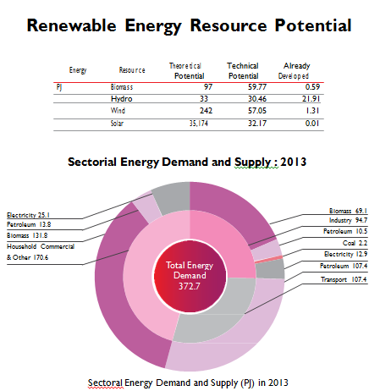

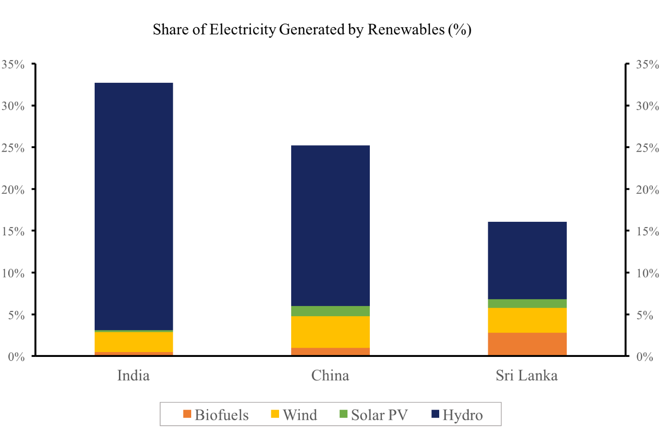

This graph indicates the transition to Renewable Energy in India, Sri Lanka, and China

* This graph shows that Sri Lanka is lessly using renewable energy compared to India and China.

# Conclusion

Energy demand in Sri Lanka is increasing at the same rate as in other countries, so energy must be conserved to protect our environment from drastic changes and to save depleting resources for future generations. The rate at which energy is produced and consumed can harm our planet in a variety of ways. In other words, it aids in the preservation of the environment. We can mitigate these effects by using less energy. Every year, the cost of energy rises. We must understand how energy can be used to our advantage and how we can avoid wasting it.

Another prominent strategy is to use renewable energy. Sri Lanka's vast renewable energy resource base will be developed to increase indigenous energy's dominance in both electricity and thermal energy supplies. This initiative will cover the entire value chain of the electricity sector, from remote electrification via off-grid solutions to large-scale infrastructure development to absorb wind, solar, remaining hydro, and other renewable energy resource-based power generation to the national grid.

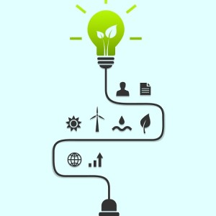The availability of a resource, whether local or global, is not always the only factor considered when using it as an energy supply source. More importantly, the use must be cost-effective in comparison to other available sources. As a result, the technology available for converting the resource to a more usable form is critical in selecting an energy resource for energy supply. Changes in technology and resource availability over time can alter the economics of using the resource for energy supply. As a result, the resources used by a country to meet its energy needs change over time.

**References**

[1] Dulip Jayawardena 2010, ‘Potential for renewable energy in Sri Lanka’, Business Times, October 31, p.1, viewed 15 September 2016, <http://www.sundaytimes.lk/101031/BusinessTimes/bt09.html>.

[2] Garrett Richards, Bram Noble & Ken Blecher 2012, ‘Barriers to renewable energy development: A case study of large-scale wind energy in Saskatchewan, Canada, vol. 42, pp. 691–698.

[3] Oshani Perera 2016, ‘Investing in sustainable energy: The case for solar technology in Sri Lanka, April 23,viewed14Septembe2016, <http://www.ft.lk/article/537645/Investing-in-sustainable-energy:-The-case-for-solar-technology-in-Sri-Lanka.html>.

[4] Adaderana 2015, ‘Sri Lanka targeting affordable renewable energy’, June 10, viewed 17 September 2016, <http://www.adaderana.lk/news/31206/sri-lanka-targeting-affordable-renewable-energy.html>.

[5] The curionomist, 2015, ‘Enhancing Knowledge Capacity for Sri Lanka’s Energy Sector: Takeaways from the Energy Symposium’, July 1, viewed 14 September 2016, [https://thecurionomist.wordpress.com/2015/07/01/enhancing-knowledge-capacity-for-sri-lankasenergy-sector-takeaways-from-the-energy-symposium.html.](https://thecurionomist.wordpress.com/2015/07/01/enhancing-knowledge-capacity-for-sri-lankasenergy-sector-takeaways-from-the-energy-symposium.html.%20)

[6] Renewable Energy World Editors 2015, ‘10 Most-read Articles of 2015 on Renewable Energy World’, December 25, viewed 15 September 2016, <http://www.renewableenergyworld.com/articles/2015/12/10-most-read-articles-of-2015-on-renewableenergyworld.com.html.>

[7] Philip Jennings 2009, ‘New directions in renewable energy education, pp 435–439, Physics and Energy Studies, Murdoch University, Murdoch, WA 6150, Australia

[8] Prevention of energy crisis in Sri Lanka -Daily mirror